HTML

**MODULE -1**

**1). Are the HTML tags and elements same thing?**

**ans. HTML tags are used the to hold the html element.**

**HTML element holds the content. HTML attributes are**

**used to describe the characteristic of an HTML elements**

**in detail. Whatever written within a HTML tag are HTML**

**elements .**



**2).What are tegs and attributes in HTML ?**

**ans.HTML tag are hold HTML element.HTML element holds**

**the content. HTML attribute are used to describe the**

**charcteristic of an HTML element in detil.HTML tag start**

**with <and ends with> whatever written within a HTML tag**

**are HTML element.**



**3).WHAT are the void element in HTML?**

**ans.A void element whose content model never allows**

**it to contents under any circumstances. void element**

**can have attributes. The following is acomplete list of the**

**void element in the HTML :base , br , col, area, command, hr,**

**embed ,image ,keygen ,link , param ,link ,meta ,source ,tarck ,**

**wbr.**

**4). What are HTML Entities?**

**ans. An HTML entity is pieces of text ("string") that begins**

**with an ampersand (&) and ends with a semicolon (;)Entities**

**are frequently used to display reserved characters (which would**

**otherwise be interpreted as HTML code), and invisible characters**

**(like non-breaking spaces).**

**5). What are different types of lists in html?**

**ans. There are three typs of list in html:-**

**1.Unordered list- Used to group a set of related items in no**

**particular order.**

**2. Ordered list - Used to group a set of related itmes in**

**specific order.**

**3.Description list- Used to display name /value pairs such**

**As tems and definition.**

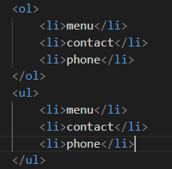

**6).What is the 'class' attribute in HTML?**

**ans. Definition and usage. The class attribute specifies one or**

**more class names for an element. the class attribute is mostly**

**used to point to a style sheet. However, it can also be used by a**

**java script to make change to HTML elements with a specified**

**Class.**

**7). What is the differnce between the 'id' attribute and the 'clas'**

**attribute of HTML elements?**

**ans. Differnce between the id and class attribute : the only diffrence**

**between them is that "id" is unique in a page an can only apply to at**

**most one alement, while "class"selector can apply to muliple elements.**

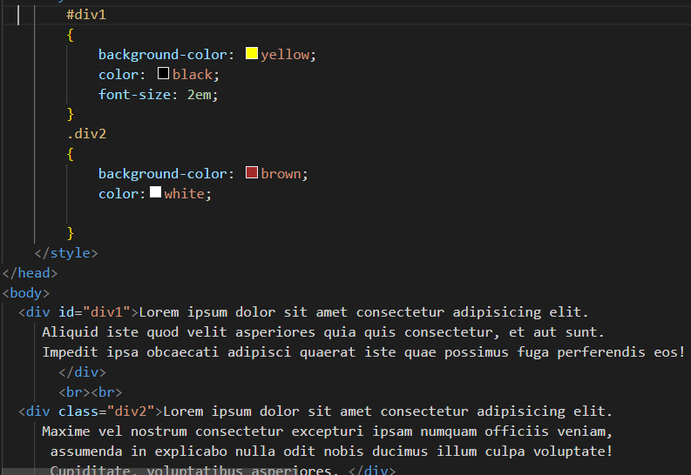

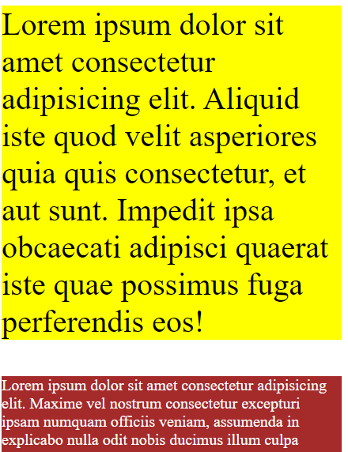

**8).What are the various fomating tags in html?**

**ans. Formatting elements were designed to display special typs of**

**text :**

**<b>- bold text**

**<i>-italic text**

**< strong >-important text**

**< em >-Emphasized text**

**< mark >- Marked text**

**< small >-smaller text**

**<del>- deleted text**

**<ins>-inserted text**

**<sub>-subscript text**

**<sup>-superscript text**

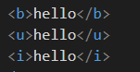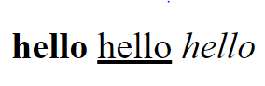

**9). How is cell padding different from cell spacing?**

**ans. Cellpadding basically defines the space present between a table**

**cell's border and the content persent in it. Cell spacing basicaly**

**defines the space present between individual adjacent cells.**

**10).How can we club two or more rows or colmns into a single row**

**or column in an HTML table?**

**ans. You can marge two or table cells in a column using the col span**

**attribute in a <td>HTML tag (table data ). To merge two or row cells,**

**use the row span attribute.**

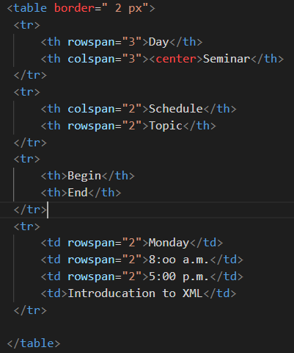

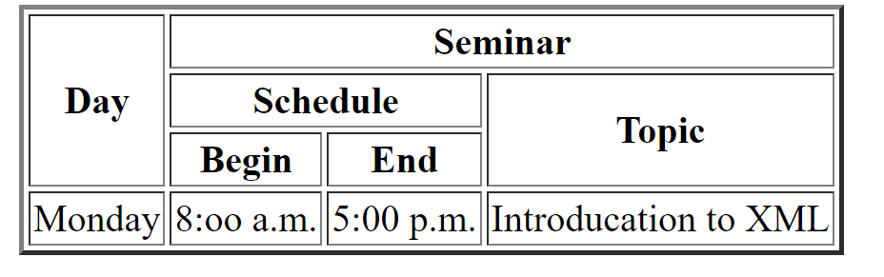**11). What is the difference between a block -level element and an inline**

**element?**

**ans. Block Elements occupy the full width irrespective of their**

**sufficiciency. inline elements don't start in a new line . Block**

**elements alwys start in a line. inline elements allow other**

**inline elements to sit behind.**

**12).How to create a Hyperlink in HTML ?**

**ans. To make a hyperlink in an HTML page, use the and tags, which**

**are tags used to define the links. The tag indicates where the hyperlink**

**starts and the tag indicates where it ends. Whatever text gets added inside**

**these tags, will work as a hyperlink. Add the URL for the link in the**

**<a href="">.**

**13).What is the use of an iframe tag?**

**ans. The tag specifies an inline frame . An inline frame is used to embed**

**another document within the current HTML document.**

**14). What is the use of a span tag? Expalin with example?**

**ans. The tag is an inline container used to mark up a part of a text ,or a**

**part of a document. The tag is easily styled by CSS or manipulated with**

**javascript using the class or id attribute.**

**The tag is much like the element, but**

**is a block -level element and is an inline element.**

**15). How to insert a picture into a background image of a web page?**

**ans. To set the background image of a web page, use the CSS style.**

**under the CSS.**

**background attribute, so CSS is used to change set background**

**image.**

**16). How are active links different from normal links?**

**ans. Those that don't have a mouse cursor over that link is**

**considered a normal link. some browser recognized active**

**links when the mouse cursor is placed over that link.**

**others recognize active links when the link has the focus.**

**Those that do not have mouse cursor over the link is said**

**to be normol link.**

**17).What are the differnt tags to separate section of text?**

**ans. There are three tags that can be used to separate the text:**

**tag-- Usually**

**tag is used to separate the line of text. it breaks the current line**

**and conveys the flow to the next line.**

**tag--This contains the taxt in the form of a new paragraph.**

**tag-- It is used to define a large quoted section.**

**18).What is SVG?**

**ans. The tag defines a container for SVG graphics. SVG has**

**several methods for darwing paths, boxes , circles, text, and**

**graphic images.**

**19).What is difference between HTML and XHTML?**

**ans. HTML is SGML --based while XHTML is XML --based .**

**They are like two sides of the same coin. XHTML was derived**

**from HTML to conform to XML standards. Hence XHTML is**

**strict when compared to HTML and does not allow user to**

**get away with lapses in coding and structure.**

**20). What are logical and physical tags in HTML?**

**Ans. Logical tags are used to provide information by giving the**

**Special importance to the text . For instance, tag is used to emphasize**

**The text by representing it in italic format . physical tags are used**

**to style the content only. For instance , is used to display the text**

**In italic format.**

